Mode | Key | Does
Edit | G | Moves the selected shape
 | R | Rotates the selected shape
 | S | Scales the selected shape
 | E | Extends the selected shape, use x/y/z to select axis
 | I | Insets the shape (sub-cut)
 | L | Selects connected planes/vertices/points
 | N | Transform properties window, including coordinates
 | K | Activate Knife Tool
 | H | Hide selected part of mesh
 | Alt + H | Show hidden parts of mesh
 | F2 | Rename Selected Item
 | Ctrl + F | Opens Fact interface  Includes option for intersect (knife) which creates an edge along face intersection points
Knife | A | Lock to Angles
Vertex | G + G | Moves a vertex along existing edges
Select | W | Change Select Shape (Box, Circle etc.)
 | Shift + D | Duplicate selected
 | Shift + R | Repeat last action
 | Shift + C | Resets 3D Cursor to 0,0,0
 | Shift + X/Y/Z | Select all axis except the one listed
 | Ctrl + M | Mirror selected along axis, use x/y/x to select axis
 | Ctrl + R | Loop Cut
 | Ctrl + I | Invert selection (unselect selected, select everything unselected)
 | Ctrl + + | Selected ring continues upwards (loop select)
 | Alt + Click | Follow along edge for select / loop select
 | \ | Isolate the currently selected object (visually)
Object | Ctrl + J | Joins two objects into one
 | Shift + A | Add a shape or object to the scene
Sculpt | Shift | Temporarily activates the smooth tool
Shading | Ctrl + J | Puts selected nodes into a group
 | F2 | Names the selected group
 | Ctrl + Click | Add colour to a colour ramp
 | Ctrl + 0 | Creates a mix RGB between two selected colours/ colour ramps

Screenshot Notes
[In Object Mode]
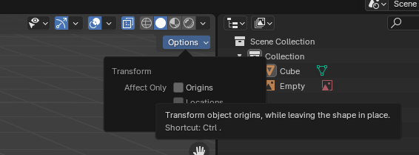
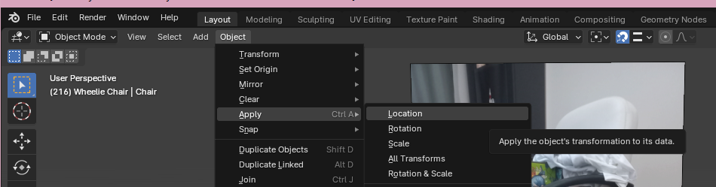
[In Edit Mode]
